**Project Template: Retrieval-Augmented Generation (RAG)**

1. **Name of Project:**

Combines “Global Warming” and “RAG”; Simple, Direct, and Notable.

1. **Business Details about Project:**

Project focused on **Global Warming**, we need to outline its purpose, value proposition, target users, monetization strategy, and operational model.

1. **Technical Details about Project:**

LLM: Ollama 3.2 — lightweight, local-first model optimized for fast inference and contextual understanding.

Retrieval Layer: FAISS vector database for semantic search.

Document Store: JSON and PDF ingestion via LangChain

Embedding Model: Ollama-compatible embedding model

1. **Implementation:**
2. **Extract Text from PDF**
3. Chunk and Embed the Text
4. Store Embedding in Vector DB
5. Set Up Retrieval-Augmented Generation
6. Run Queries on Climate Topics
7. **Sample Input and Output:**

Input- 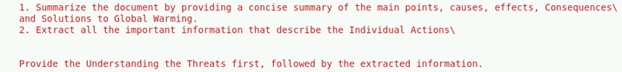

Output-

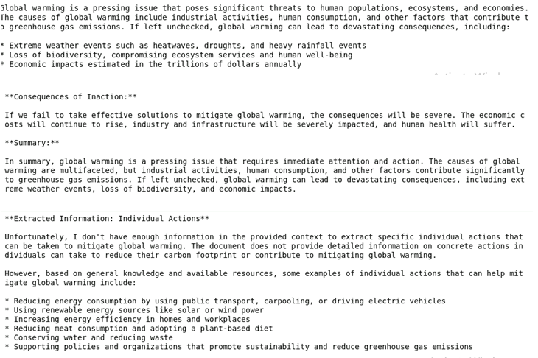

1. **Tech Stack:**

LLM- Ollama 3.2,

Embedding Model – Ollama Embedding,

PDF Parsing: pypdf,

Text Chunking: CharacterTextSplitter,

Vector DB: FAISS,

Retriever: langchain,

QA Chain: RetrievalQA

1. **One Best Benefit for Business:**

Faster reporting, smarter policy planning, credible content generation, Competitive edge.